MODULE 9:- Docker
Containerization, Docker, and Docker Hub
SUBMITTED BY :- CHANDAN YADAV KS
SUBMITTED TO :- VIKUL
DATE OF SUBMISSION :- 07-07-2025

1. L1 - Create Docker file and build the docker container Application Image for the application build in Jenkins Module
Step1:switch to root user and install docker in ubuntu machine
by the command:-1)sudo su
2)apt update
3)apt install docker.io -y
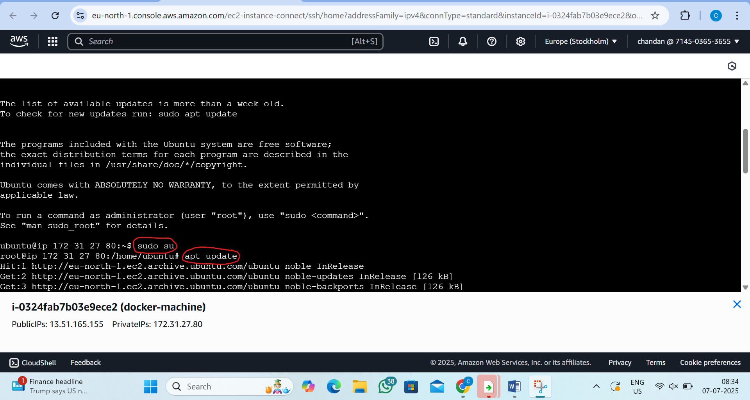

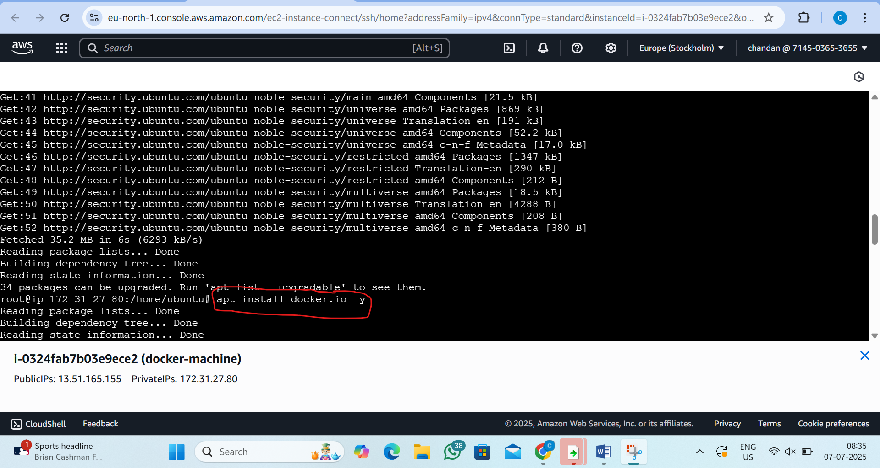
Step2:run Jenkins container
by the command:- docker run -d -p 2025:8080 --name myjenkins jenkins/jenkins
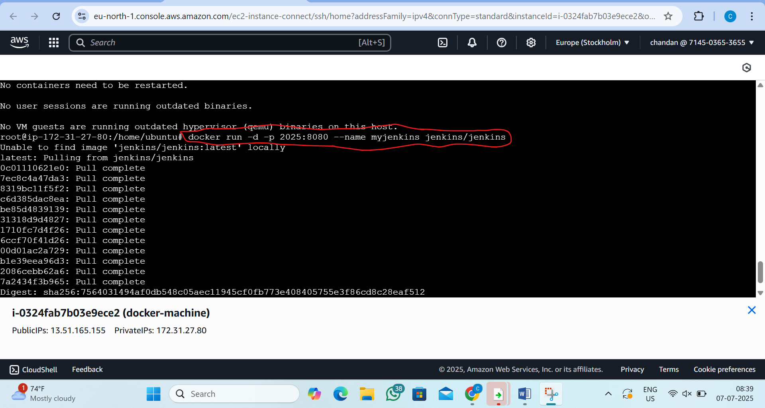
step3: Get Jenkins Admin Password and copy
by command:- docker logs -f myjenkins
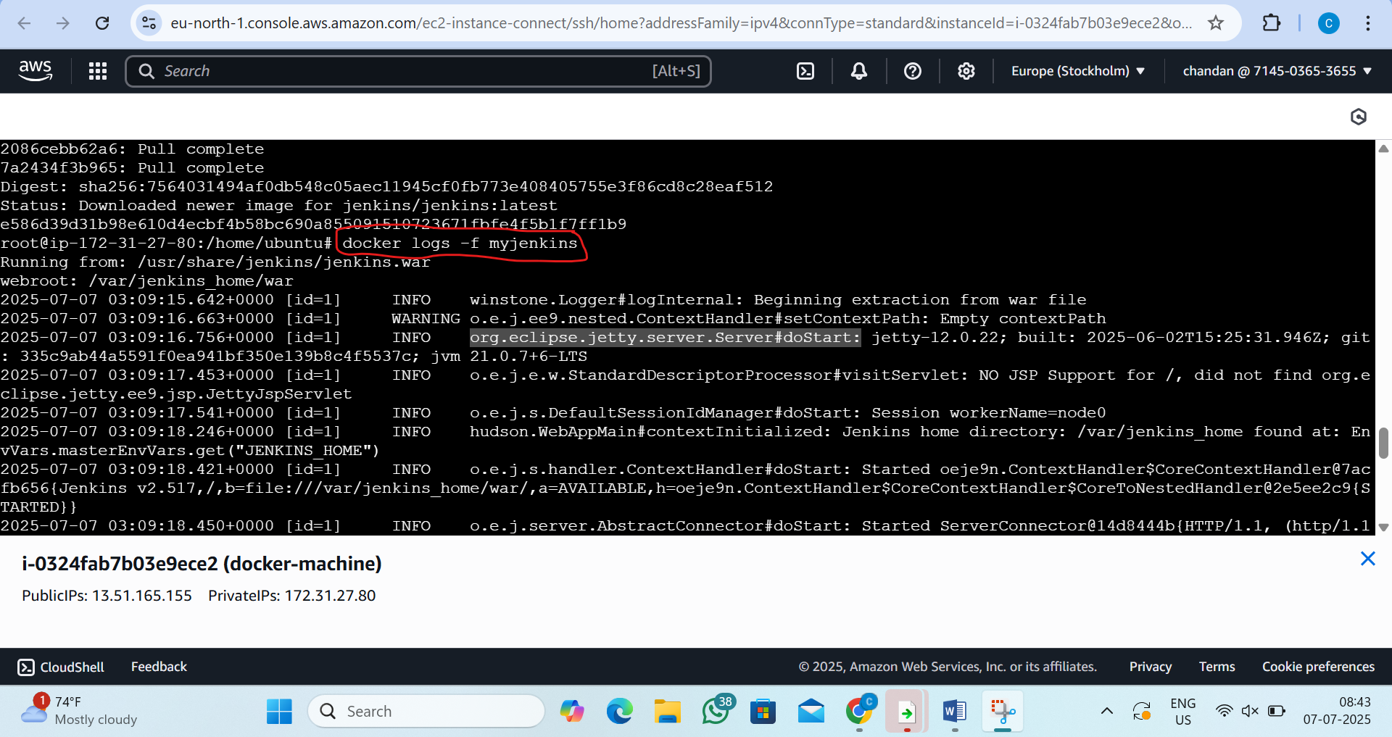
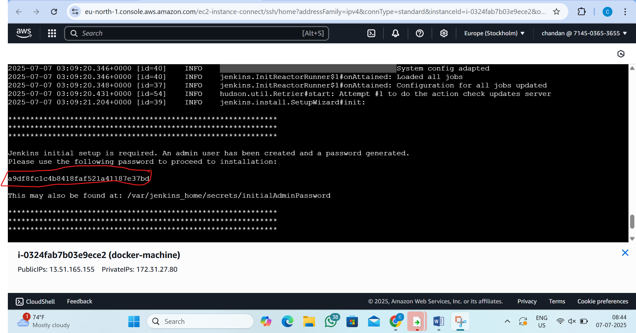

Step4:-now add the inbond rule in security group
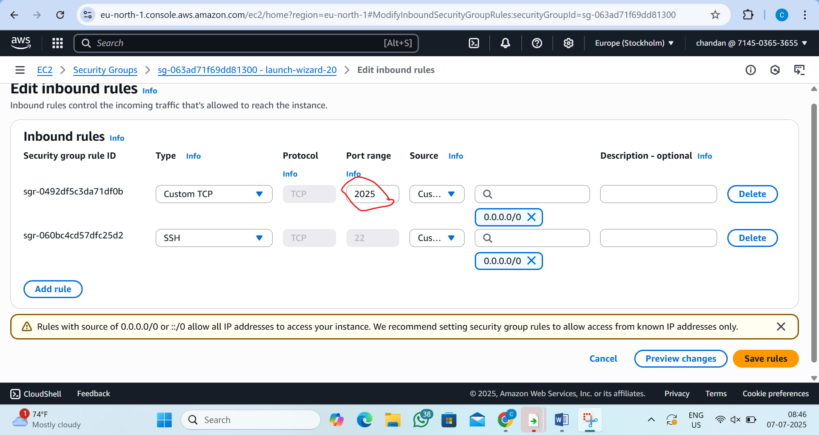

Step5:now Open Jenkins in Browser
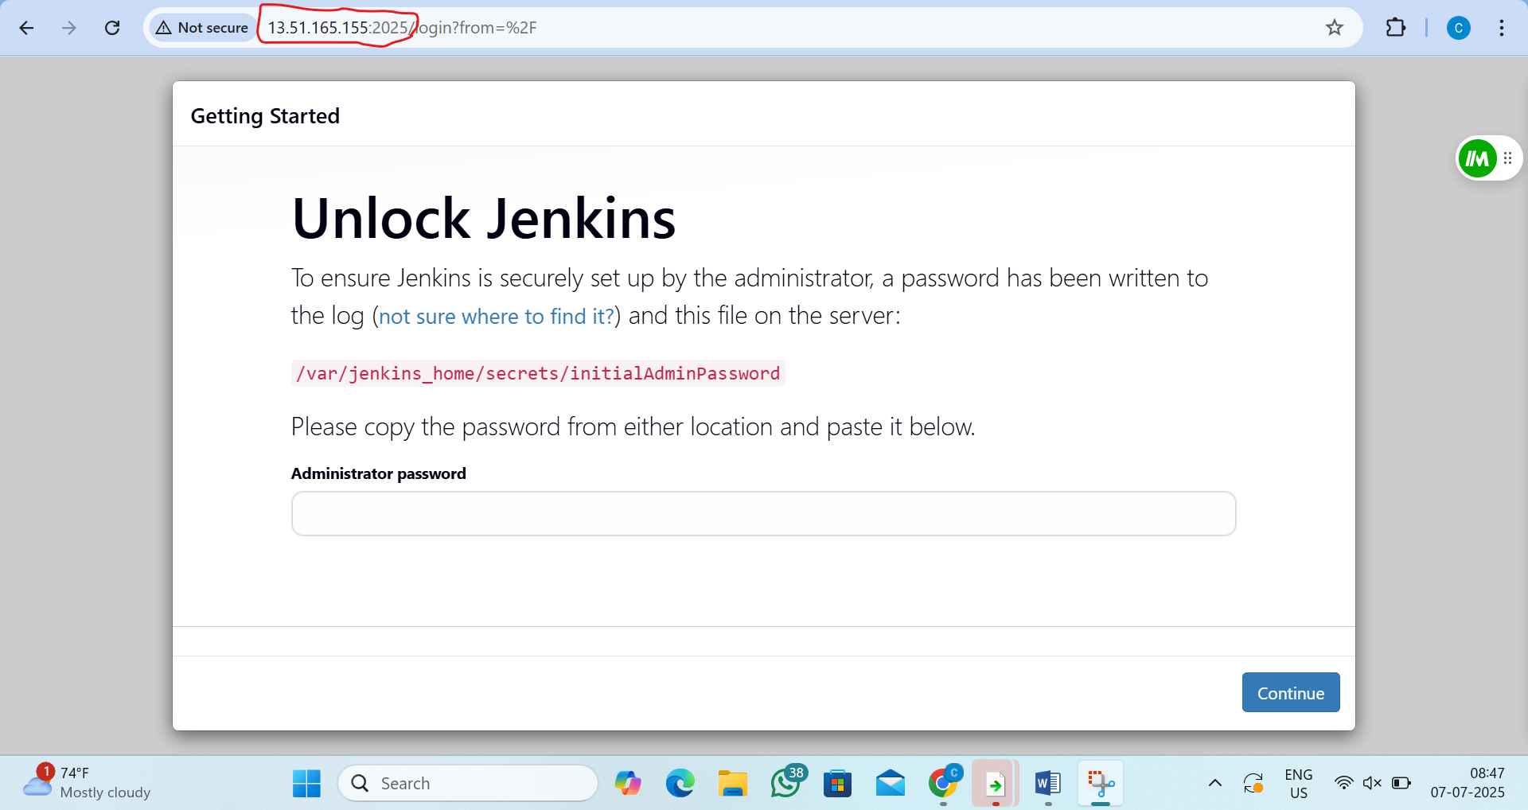

Step6:paste the admin password
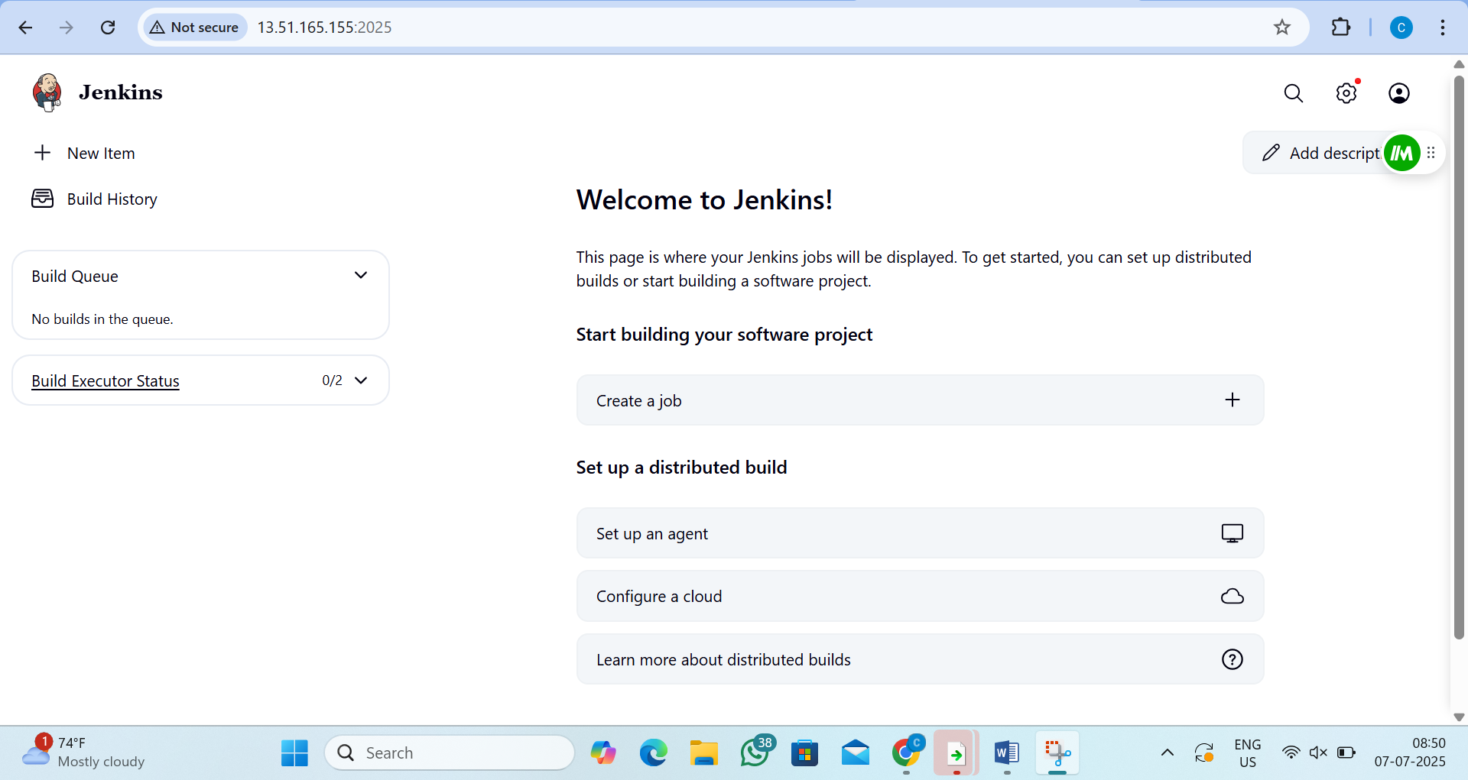

2. L2 - Create the Container using the same Application Image and run the application in a Web Browser using container port mapping
Step1:- Create a docker file
by the command:- vi Dockerfile
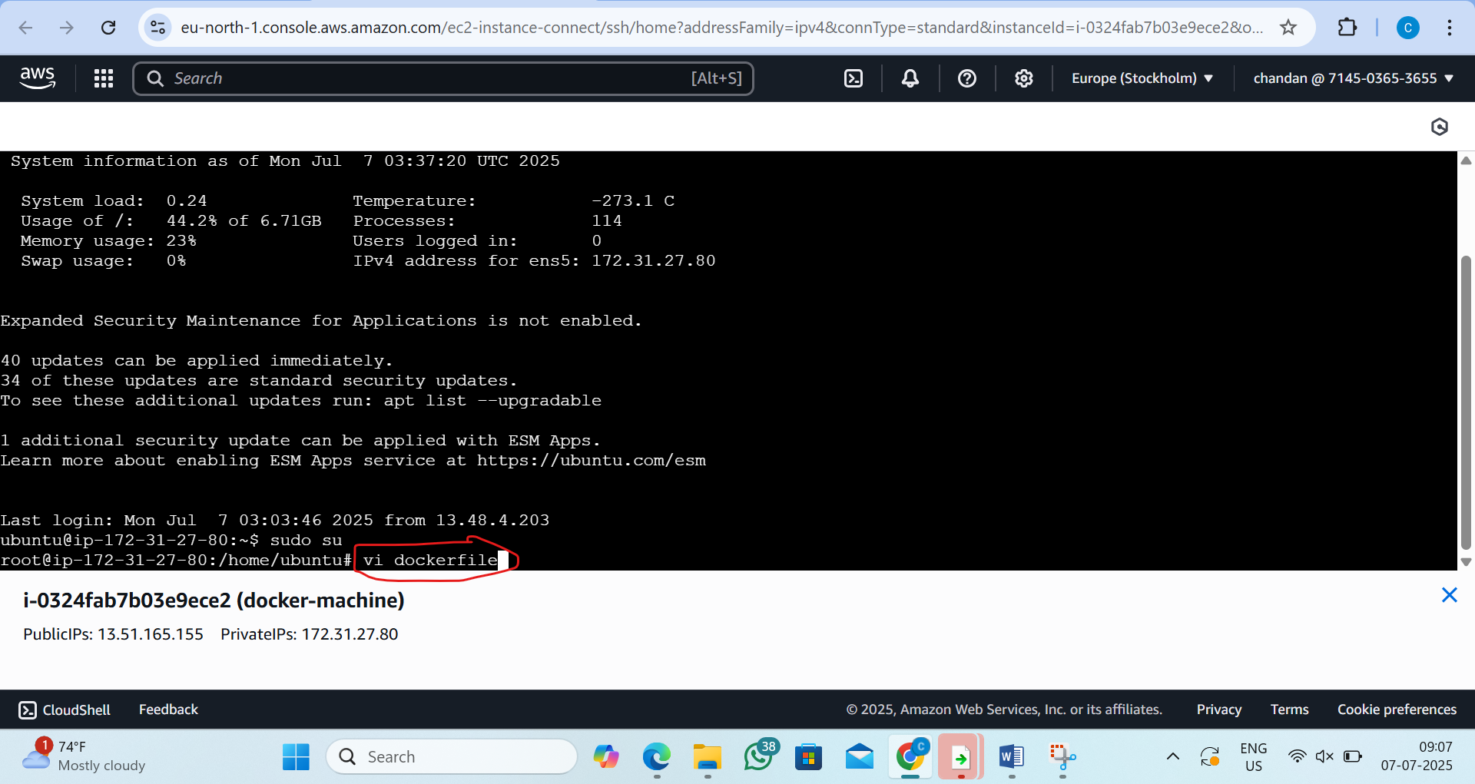
step2:inside the docker file
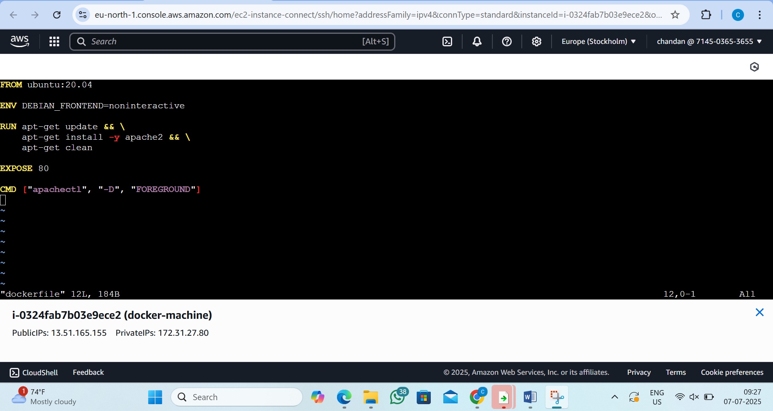

Step3: Build the Docker Image
by the command:- docker build -t myapacheimage .
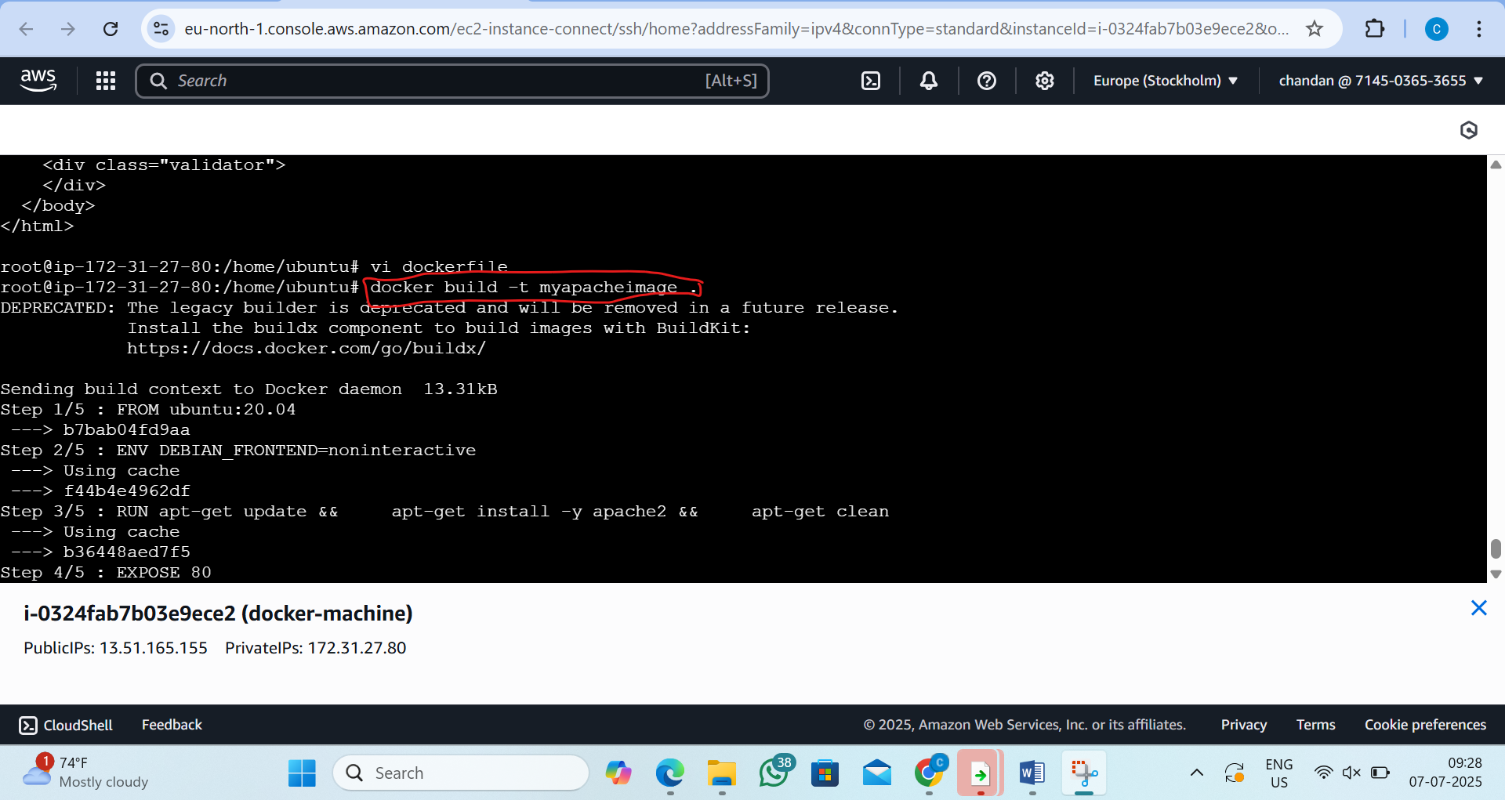

Step 4: Run the Docker Container with Port Mapping
by the command: docker run -d -p 8080:80 --name myapachecontainer myapacheimage
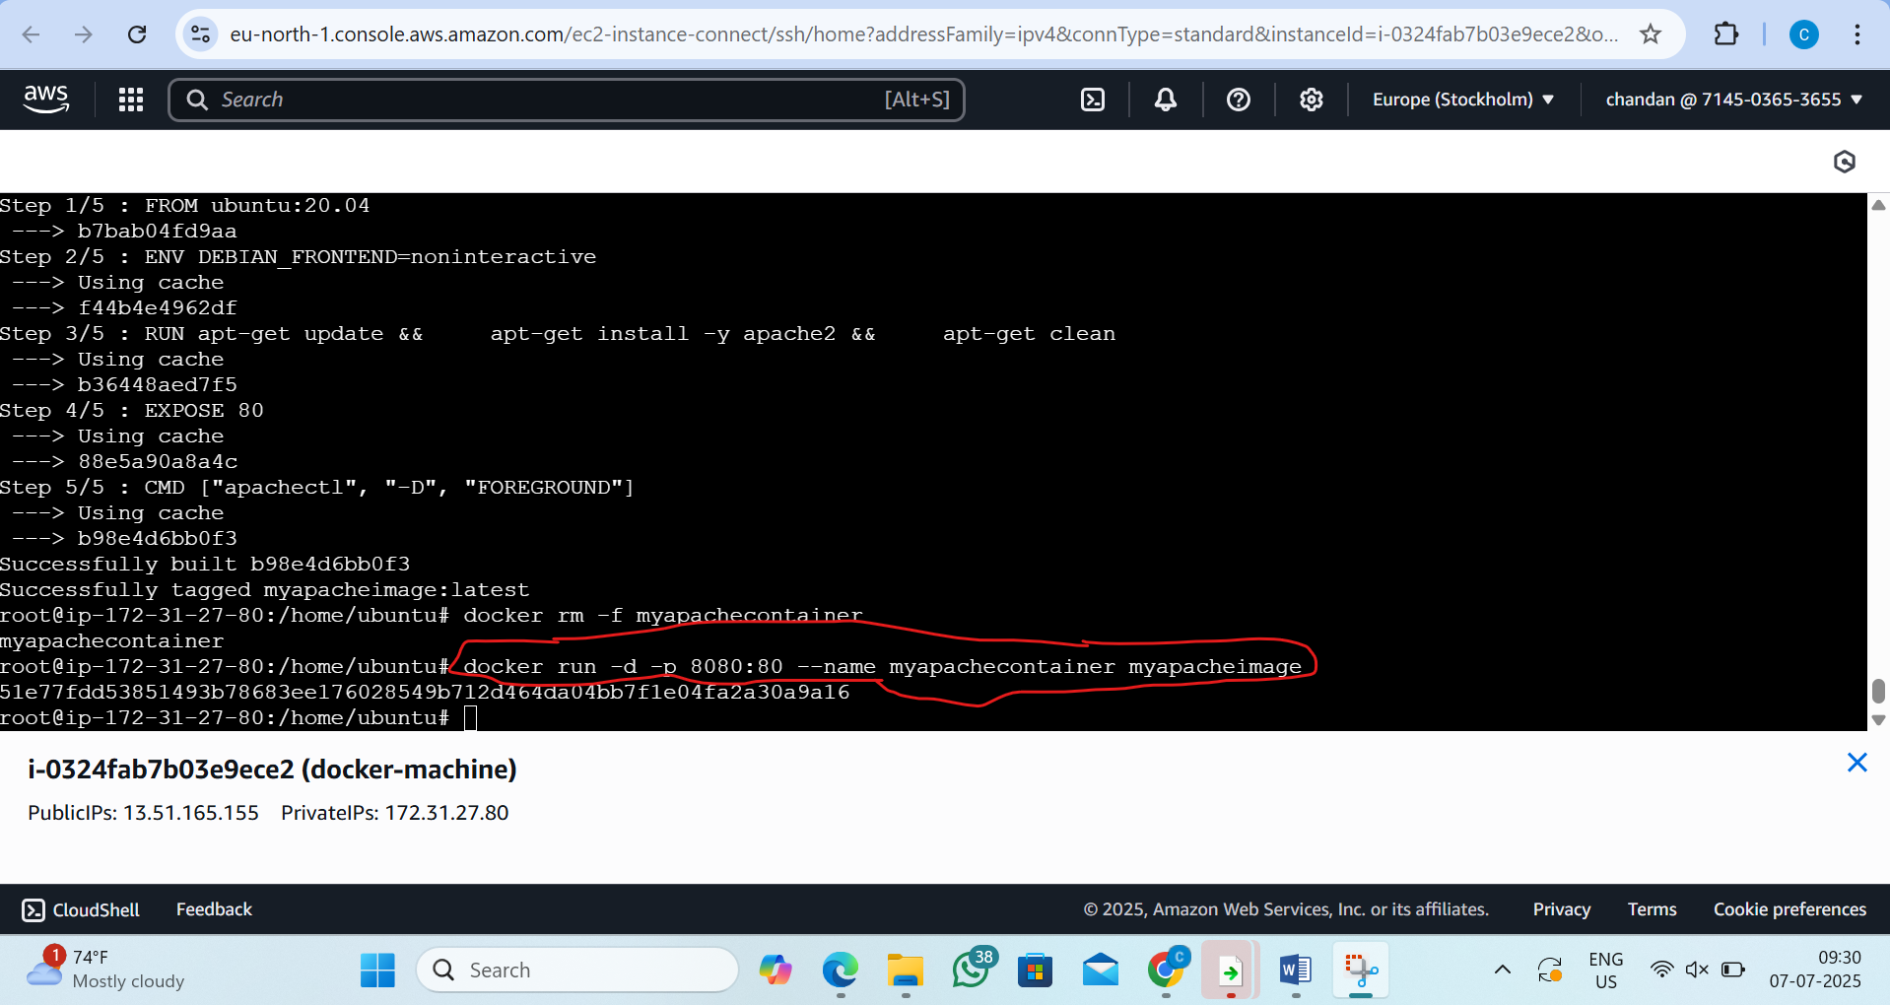

Step5: Allow Traffic in Security Group
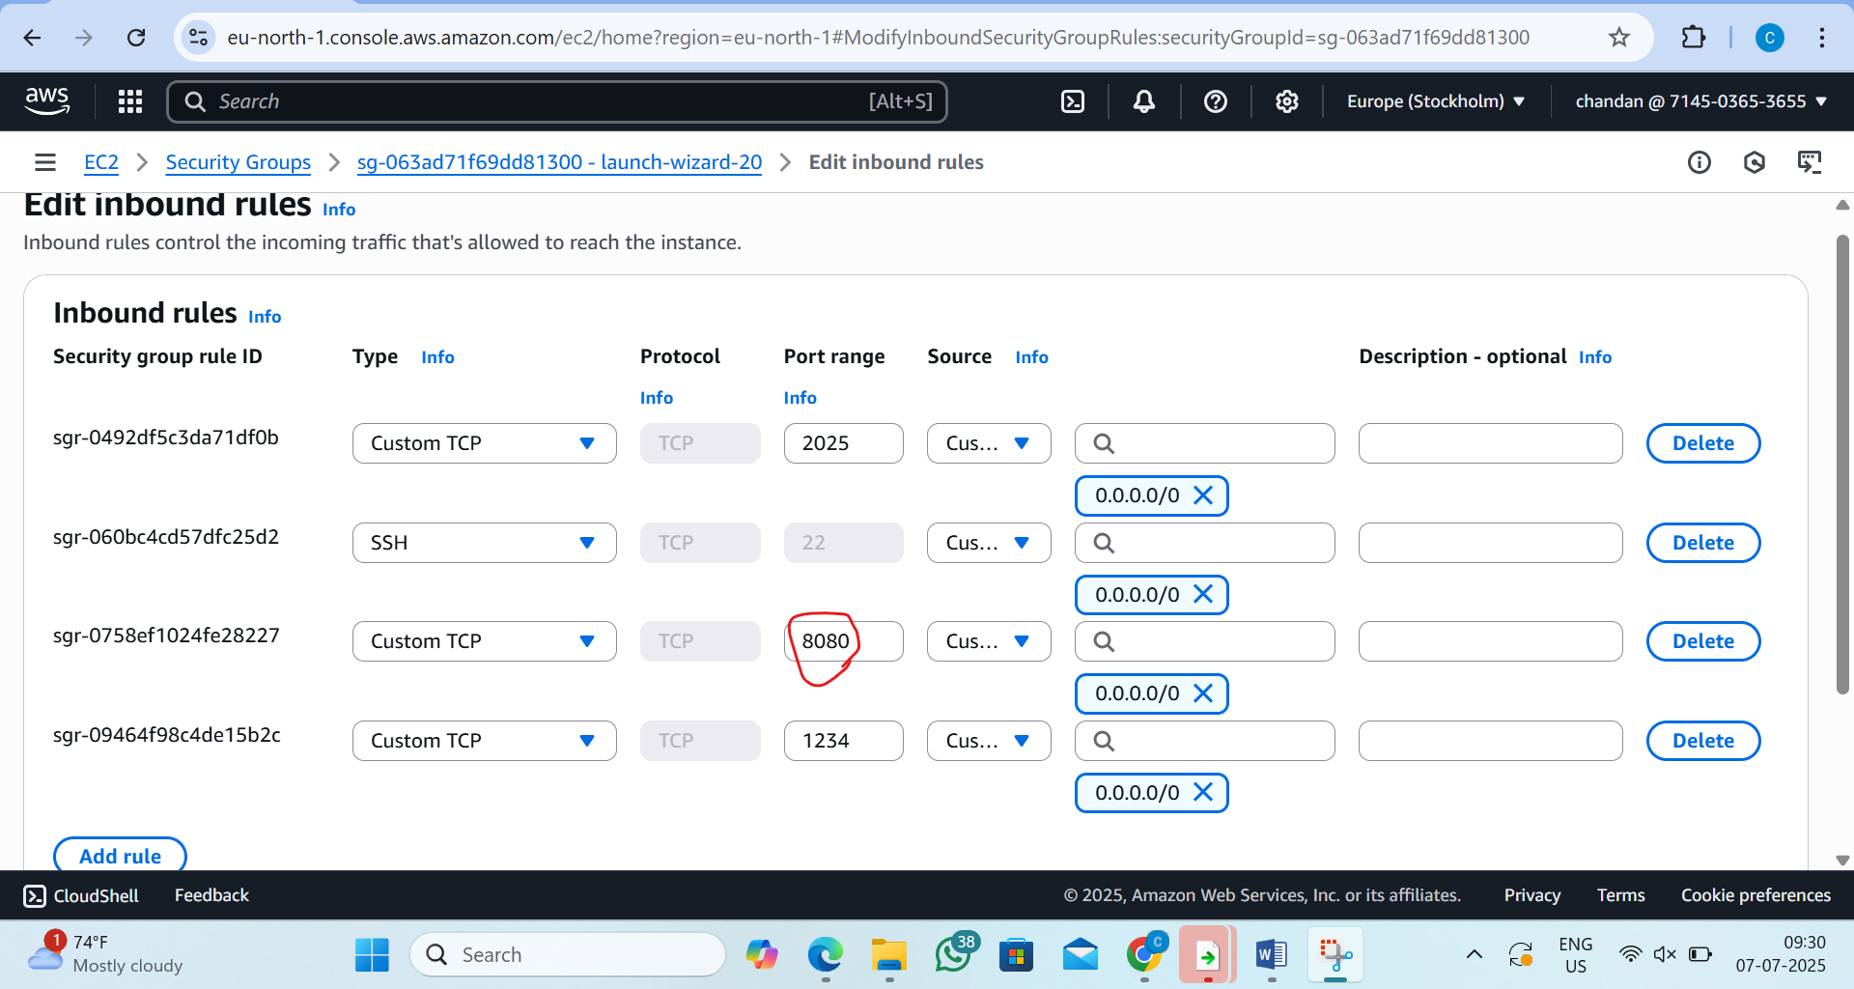
step6: Open the Web Browser
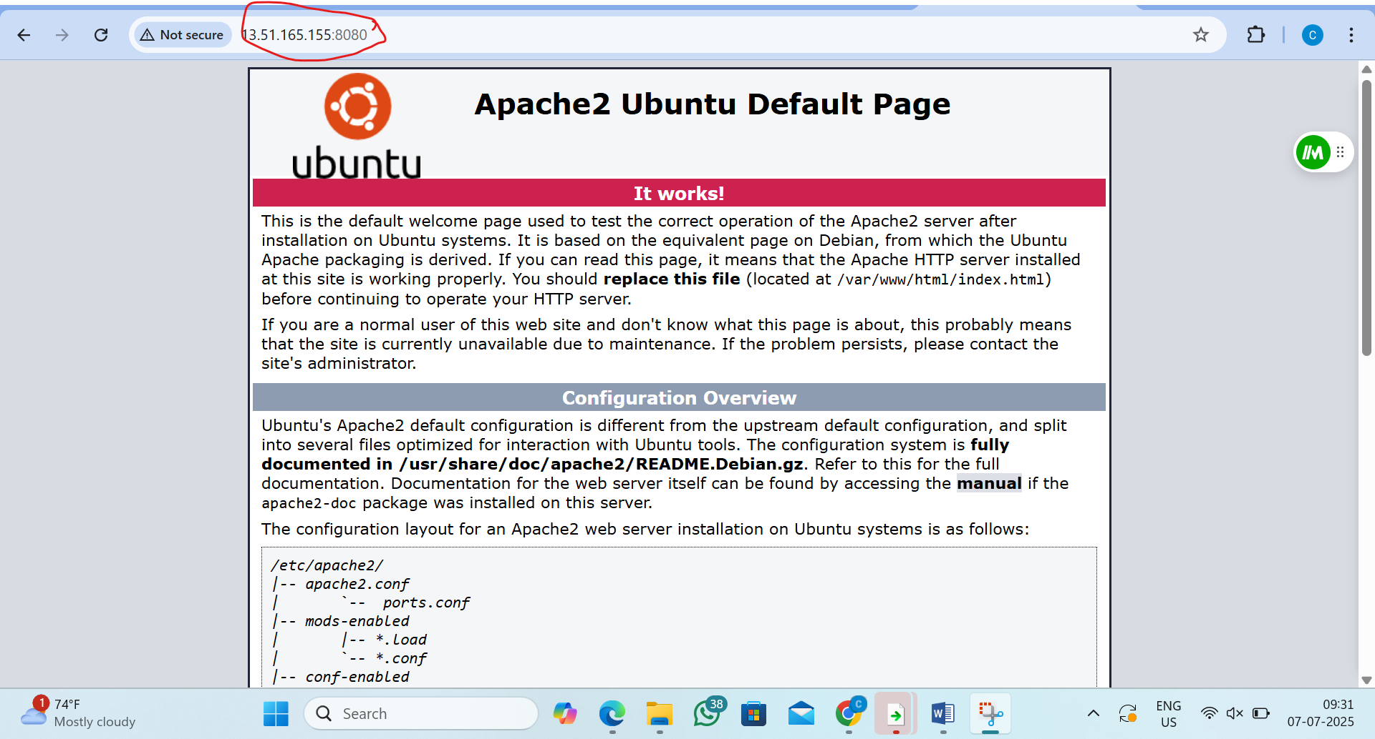

3. L3 - Demonstrate Docker Compose using the Application Image and MySQL Image to start and stop all container services
Step 1:lunch instance and go to root user
by the command:1)sudo su
2)apt update
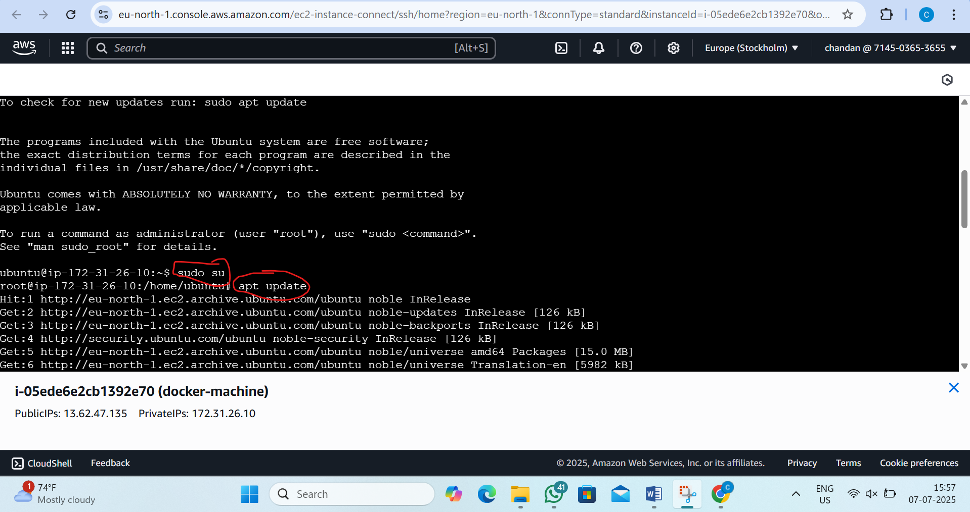
Step2: Install Docker and Docker Compose
by the command: 1)apt install docker.io -y
2) apt install docker-compose -y
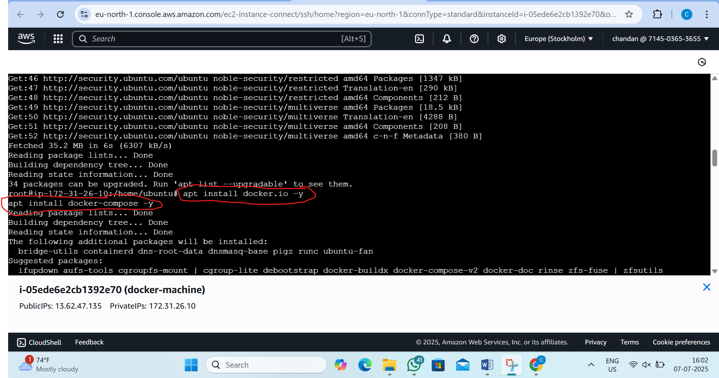
step3: Create Project Folder
by the command: 1)mkdir docker-compose-lab
2) cd docker-compose-lab
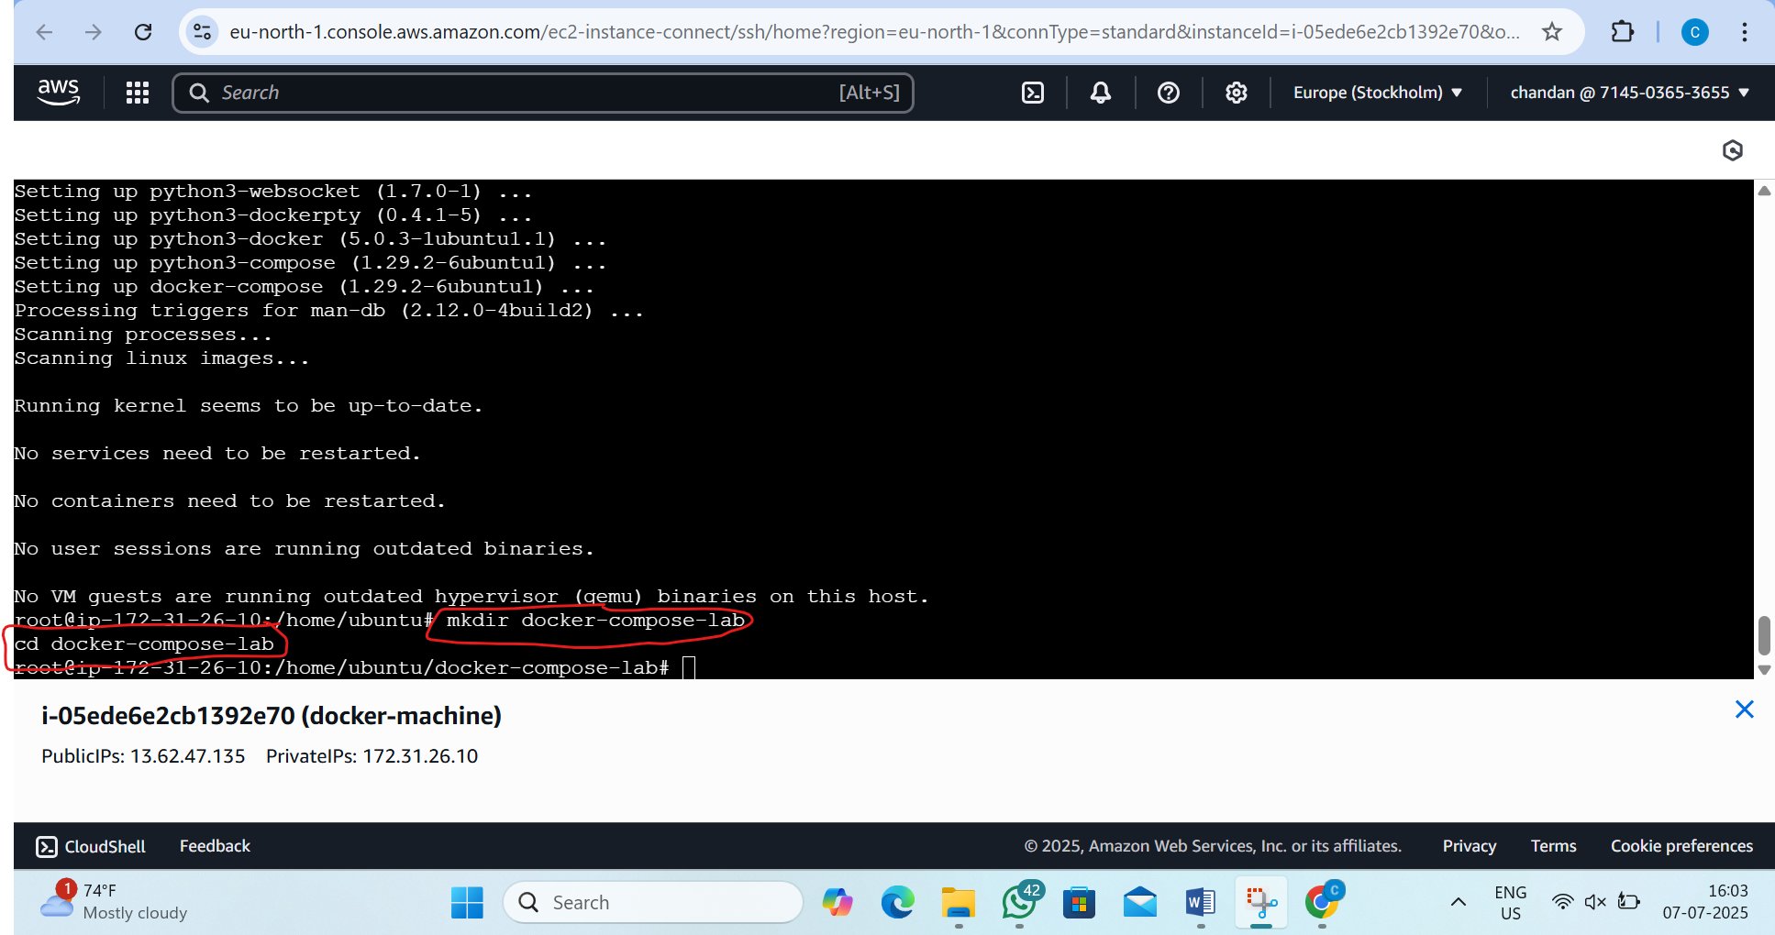
Step4: Create Application Dockerfile(this will install apache)
by the command :-vi dockerfile
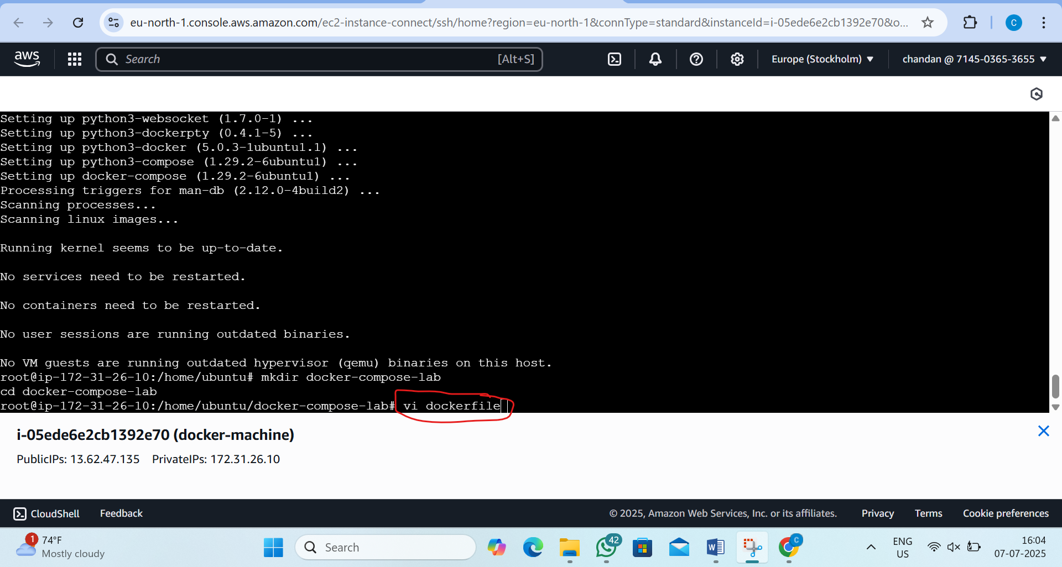
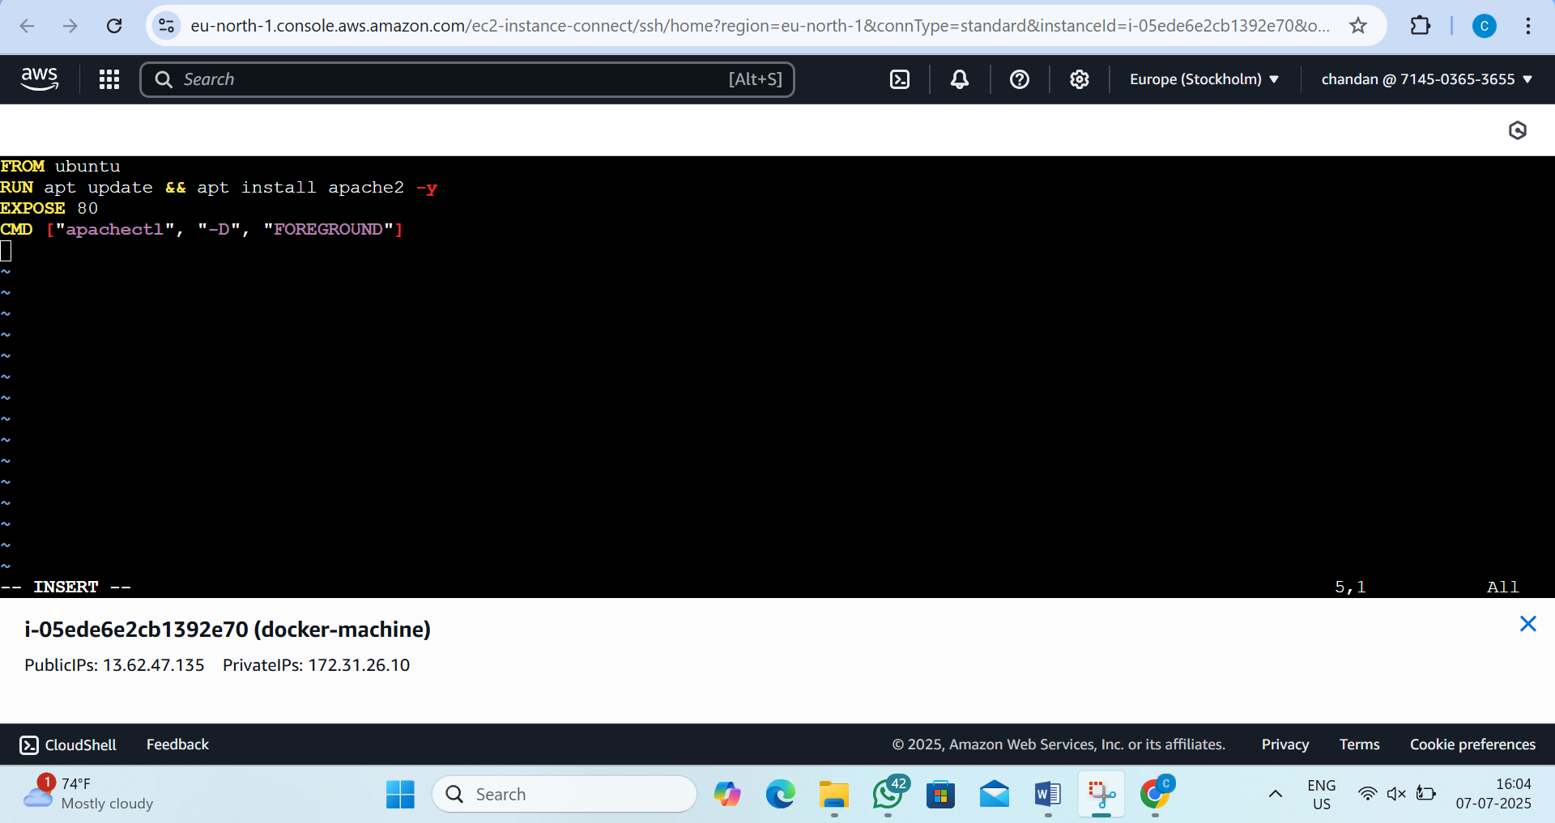
step5: Create docker compose
by the command: vi docker-compose.yml
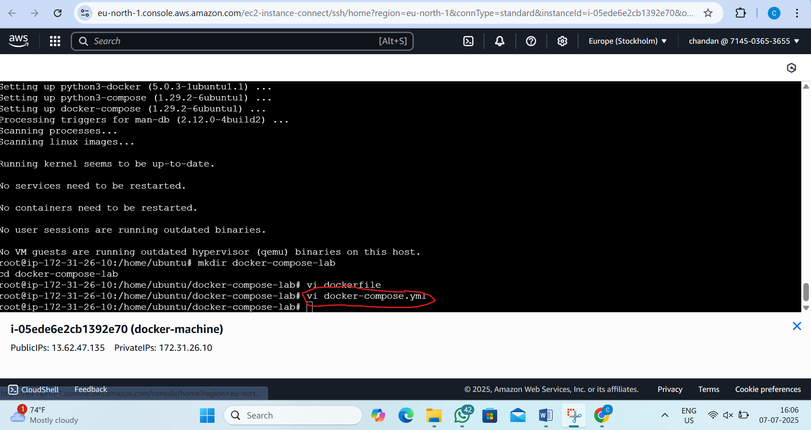
step6:inside this we want to type this
version: '3.8'
services:
app:
build: .
container_name: myapp-container
ports:
- "1234:80" # Map host port 1234 to container port 80
depends_on:
- db
networks:
- mynetwork
db:
image: mysql:5.7
container_name: mysql-container
restart: always
environment:
MYSQL_ROOT_PASSWORD: root123
MYSQL_DATABASE: mydb
MYSQL_USER: user
MYSQL_PASSWORD: user123
ports:
- "3306:3306"
networks:
- mynetwork
networks:
mynetwork:
driver: bridge
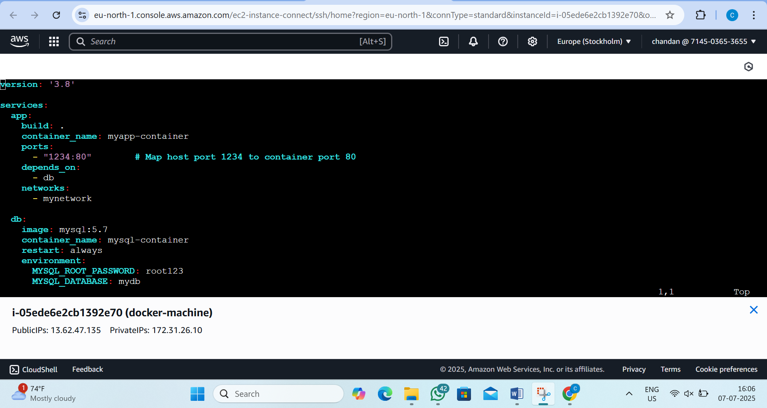
step6: Build and Run All Containers
by the command:1) docker-compose build
2) docker-compose up -d
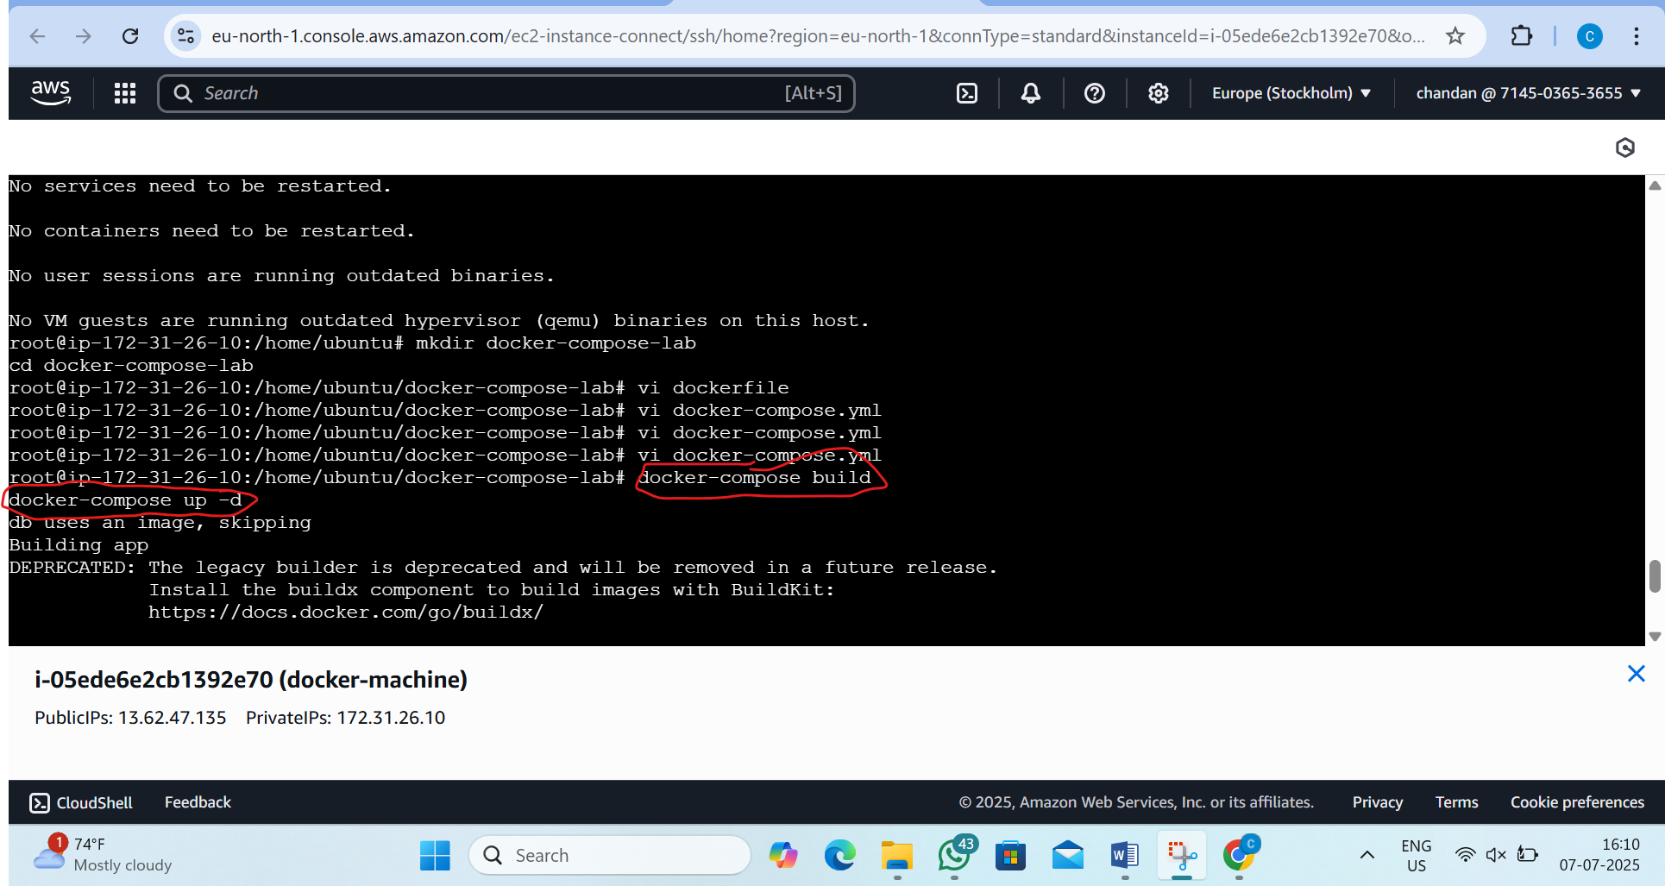

step7:now check status
by the command: docker ps
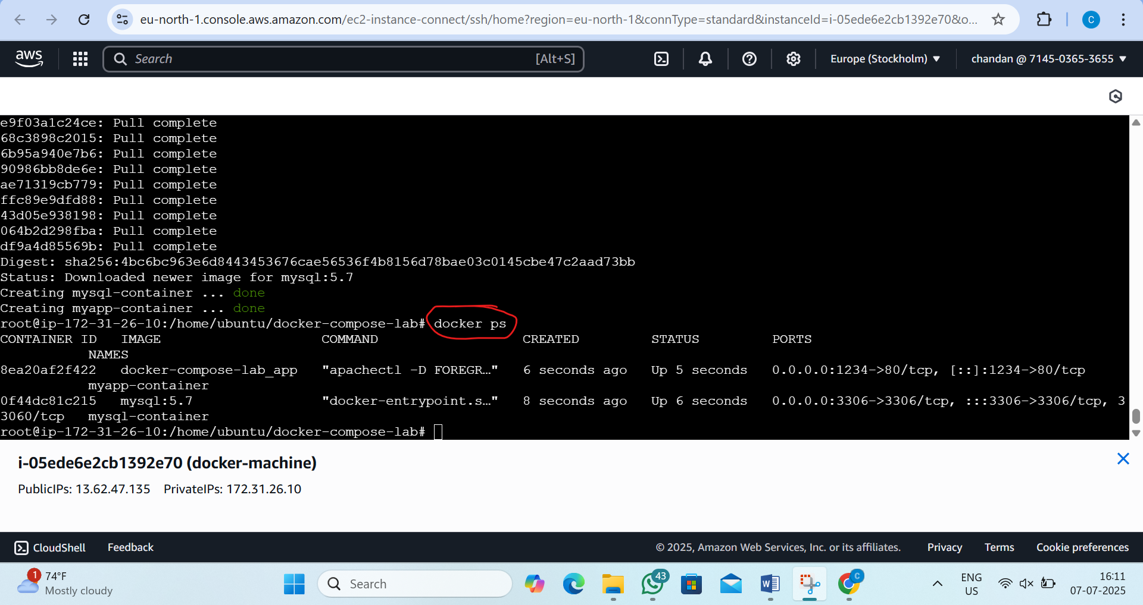

step8:now edit inbond rule and add 1234 port
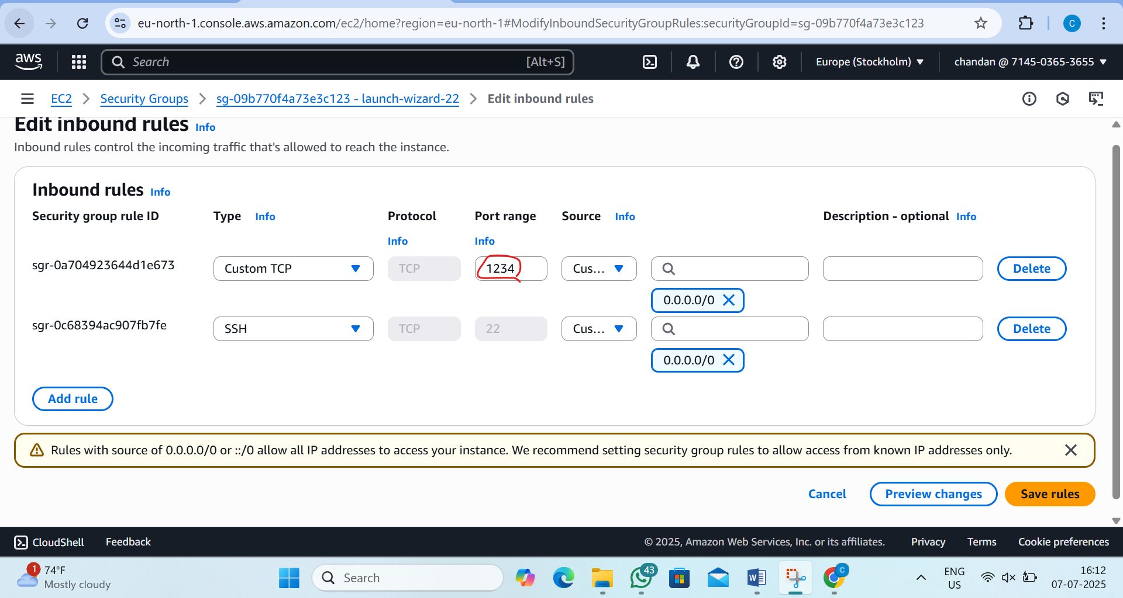
step9:now go to browser and type publicid:1234/
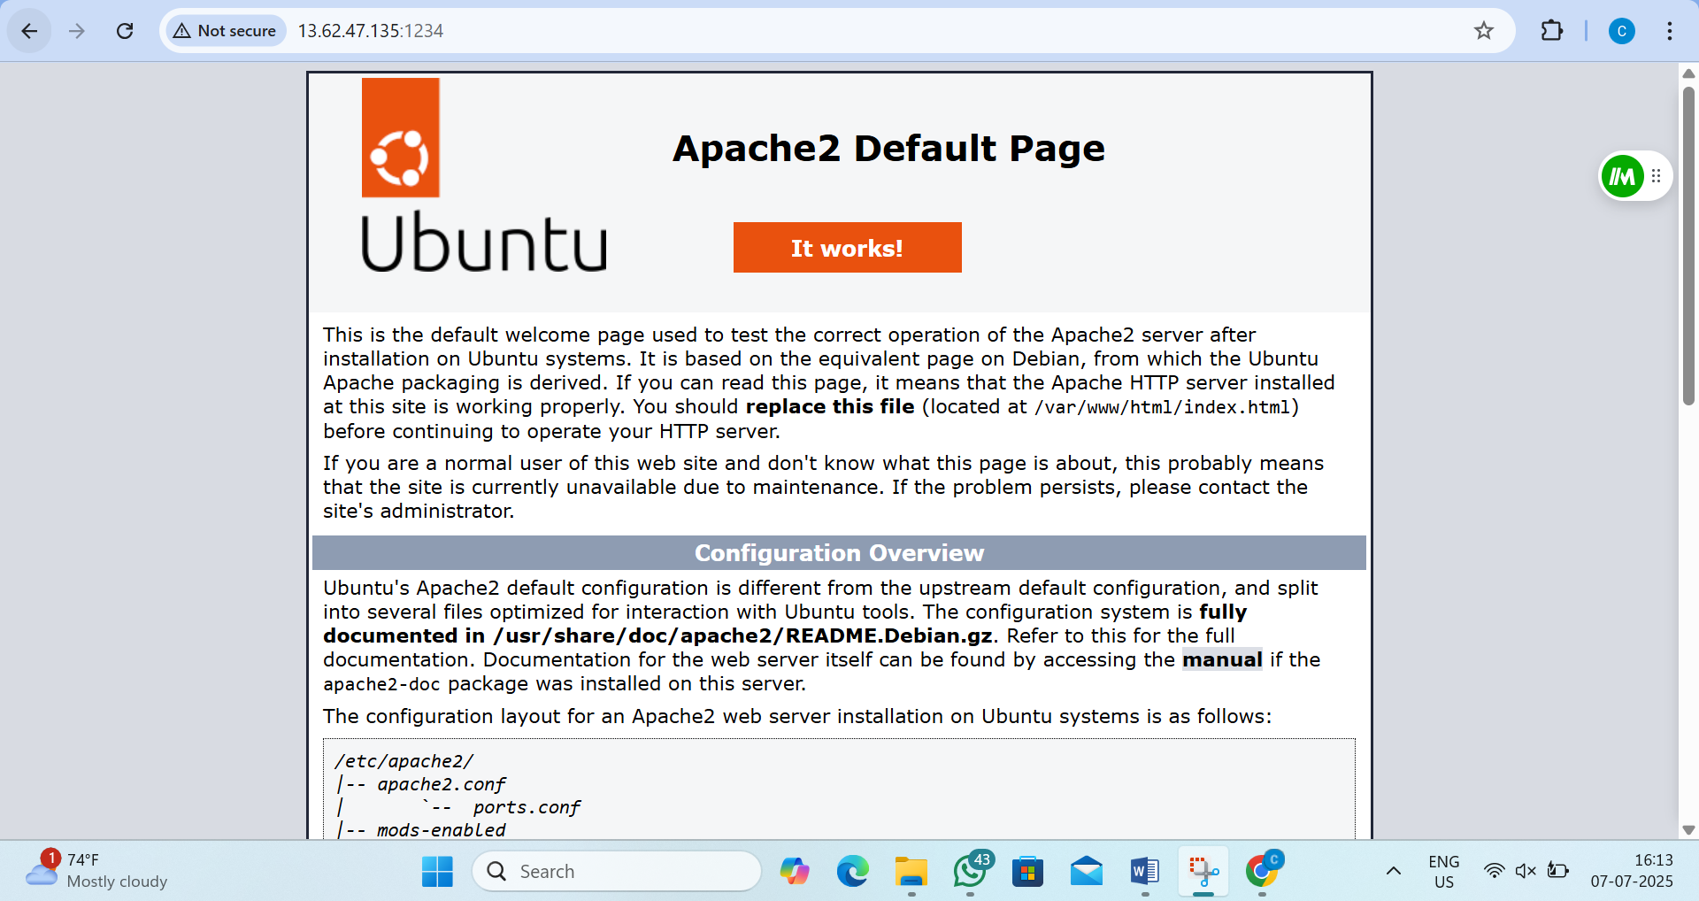
Step 8: Stop All Containers
by the command:- docker-compose down
